Hyo Park

August 31, 2020

Foundations of Programming: Python

Assignment 08

Classes

# Introduction

For module 8 we learned about objects and classes. In this paper I will talk about this week’s assignment and how I went through solving this very challenging yet, rewarding homework. It must be mentioned that I used Randal’s assignment 8 solution file and review video as a guideline for some parts of my assignment as I could not get my program to print the current list of products and its prices.

Code Set Up

Similar to past assignments, the starter file provided good foundations with its pre-code set up and pseudocodes. Because this program was similar to week 6’s assignment in set up and how it worked, a lot of the code was re-used, albeit it had to be updated as we are using classes.

Main Code

The script is organized in three phases: data, processing, and presentation. In the data part, we have the Product class, which is used to instantiate and access data. We have a __init__ constructor and setter and getter for its two attributes: product_name and product_price. My program initially could not handle any of the values I tested which I found out was due to not making the variables private.

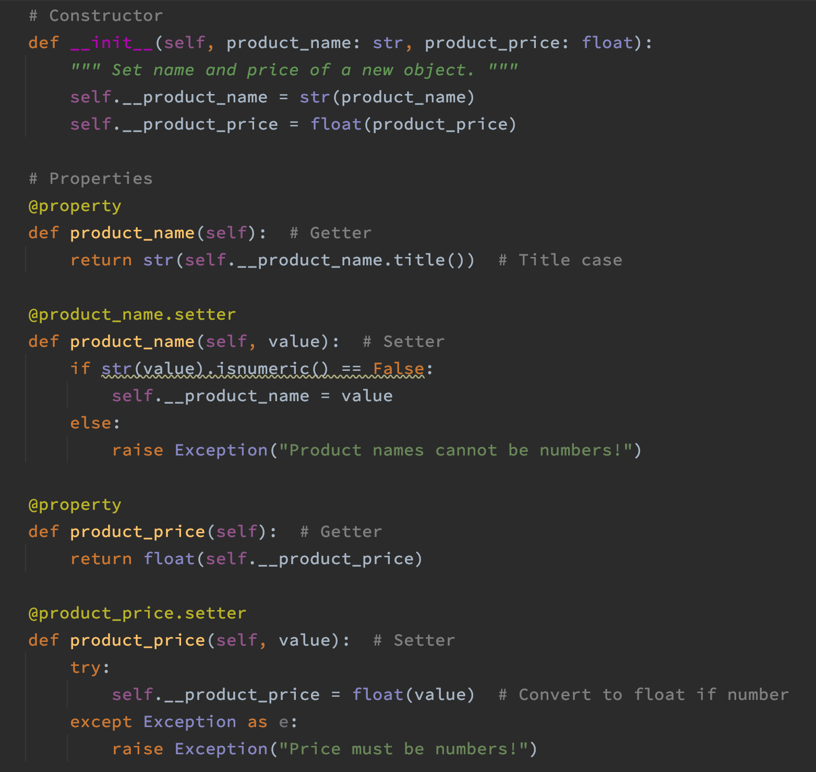

Figure 1: __init__ method with setters and getters.

Exceptions were used so in the event that non-applicable string is entered, an error message can be raised.

In the processing part of the code, we have the FileProcessor class. We have two methods, save_data_to_file and read_data_from_file, to read data from a file or to write current list of products and price to a file. This is very similar to what my code looked like for assignment 6, except that we are not using list of dictionary objects but Product class. As such, the methods invoke static method.

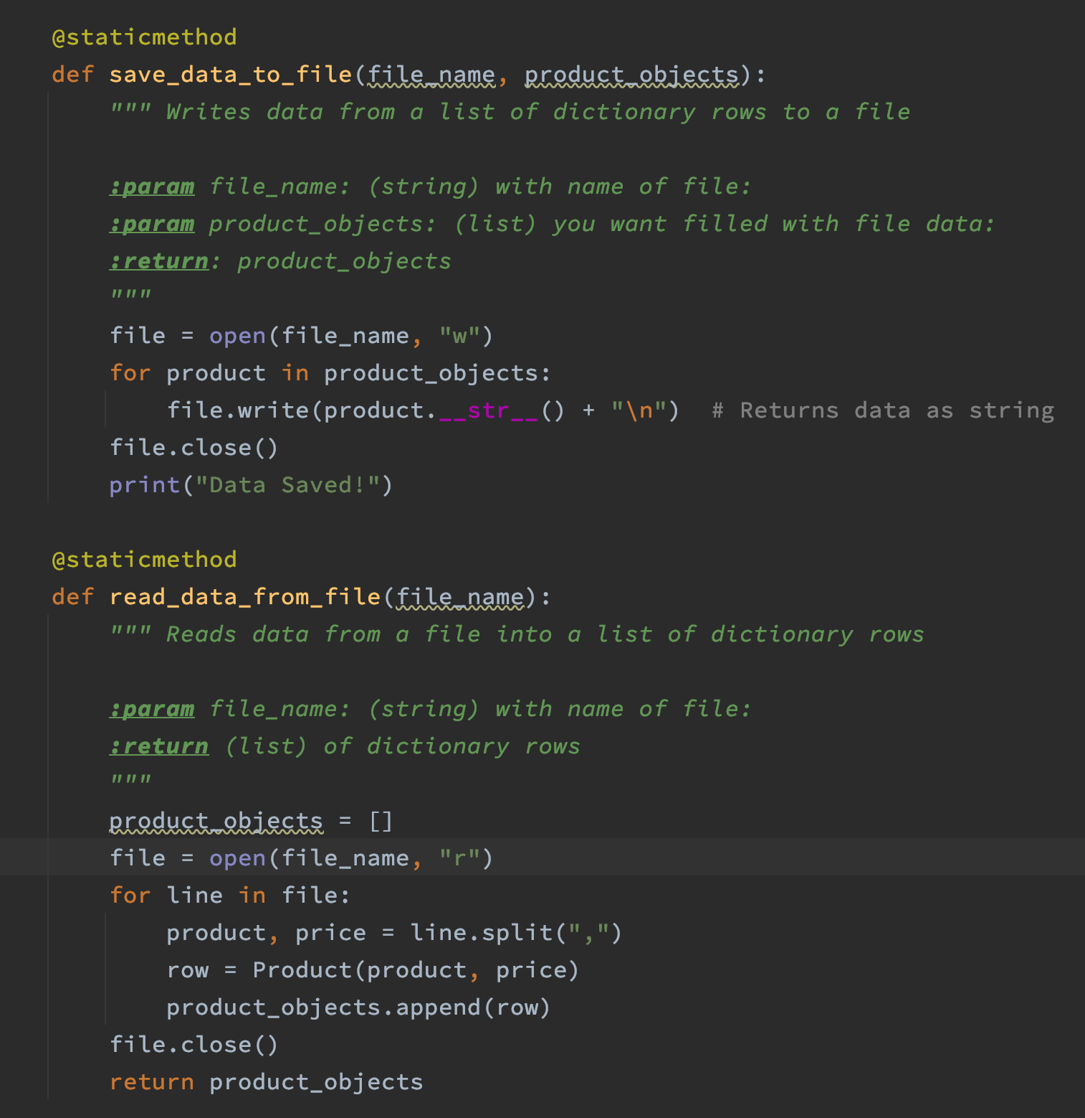

Figure 2: save_to_file and read_data_from_file methods in FileProcessor class.

Next we have the IO class in our presentation part of the code. Here we have three methods, print_menu_tasks, input_menu_choice, and input_new_product_and_price. All three are also static methods.

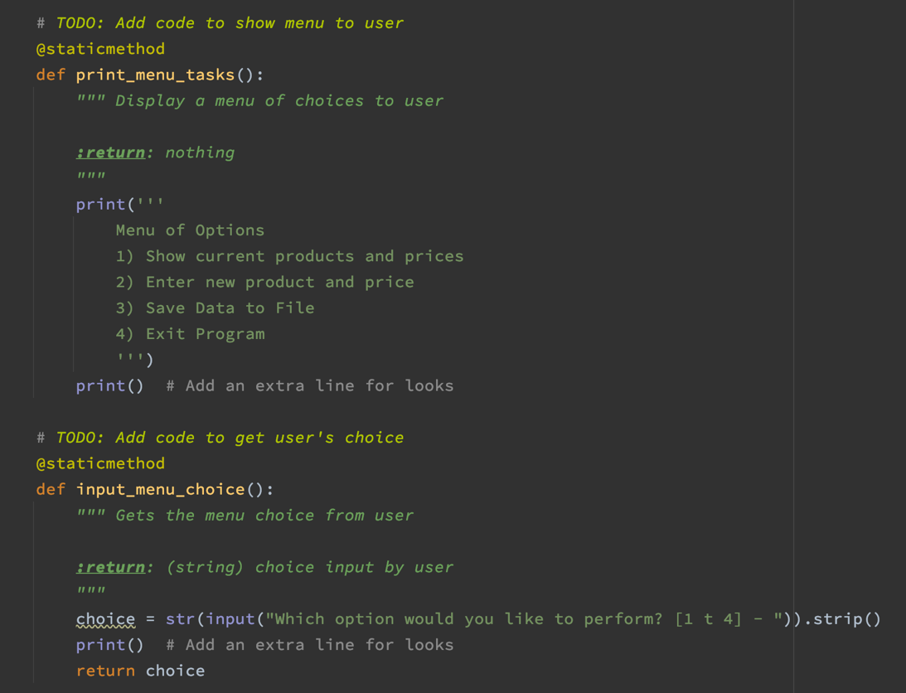

Figure 3: print_menu_tasks and input_menu_choice methods.

The print_menu_tasks and input_menu_choice methods are also similar to assignment 6. They simply print a multi-line string of menu items and prompts/returns a choice related to the menu items.

I had to watch Randal’s assignment review video to complete the next two methods, print_current_products and input_new_product_and_price. It was hard for me to grasp how to return a new set of product and price (e.g. row = Product(name, price)) and printing from a list of object (e.g. print(row.product_name + row.product_price)).

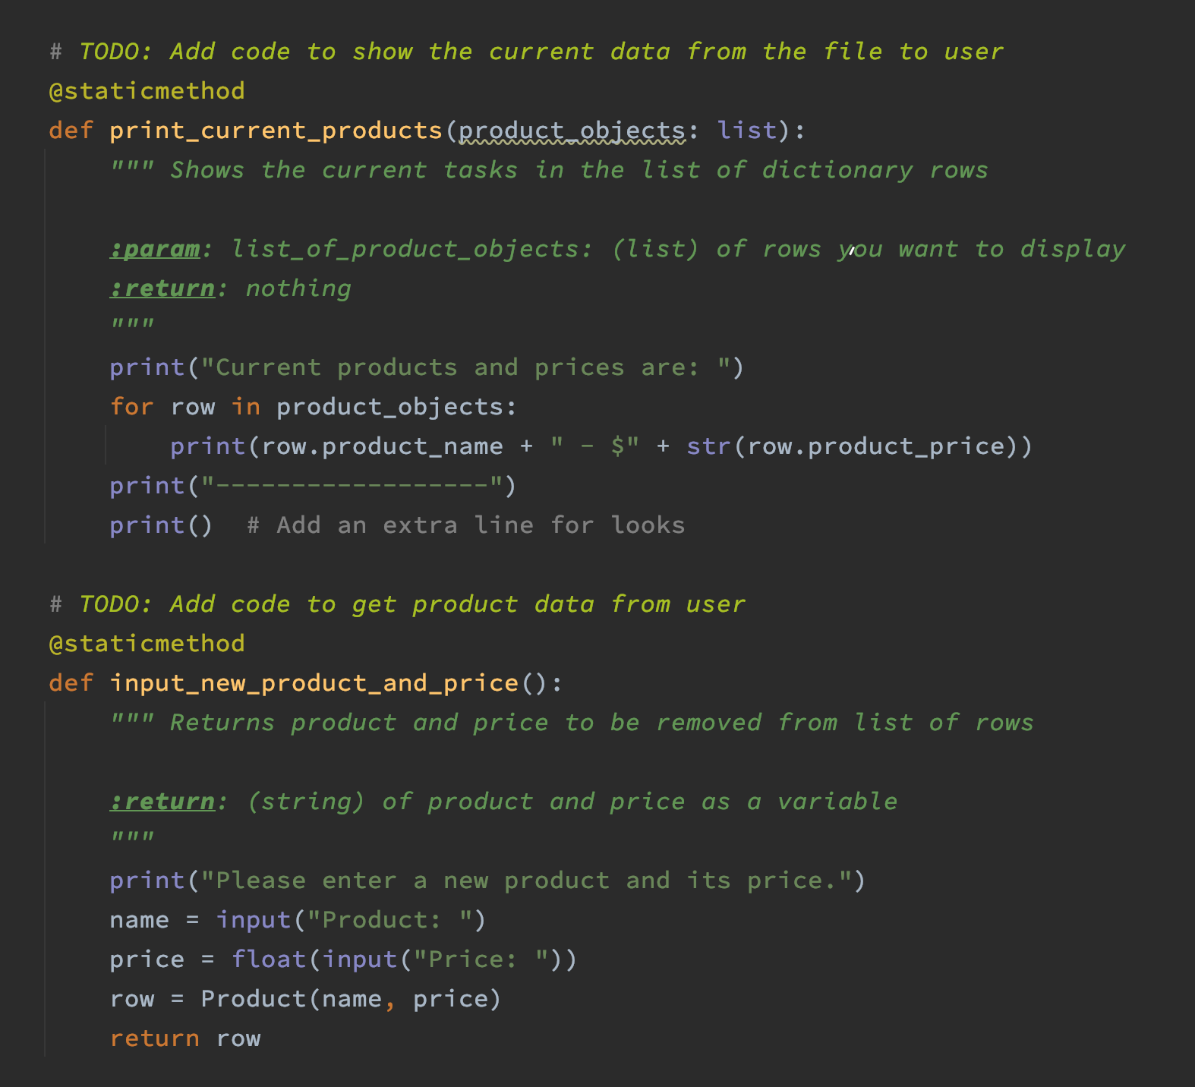

Figure 4: print_current_products and input_new_product_and_price methods

In the main body of the program, we load the txt file from memory and assign it to a variable. We then print the string menu and prompts the user for a choice. Here I had to refer to assignment 8 review code because I could not figure a way to append my new product and price to the existing list object. As seen below we are appending to the product_objects list by calling the class and method inside the append function (product_objects.append(IO.input_new_product_and_price()).

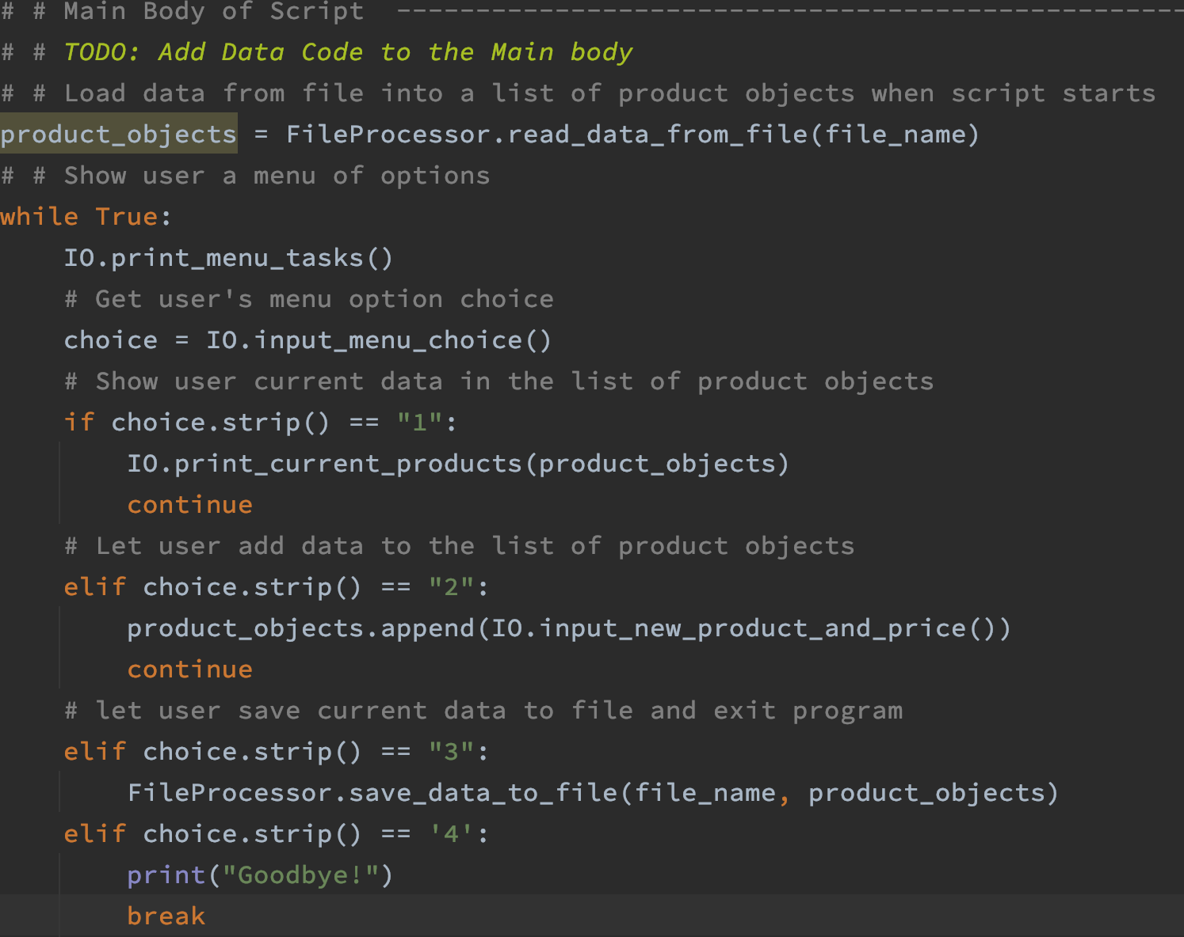

Figure 5: Main body of script

# Summary

I felt a little defeated while completing this assignment. Even the past assignments were getting more difficult as the weeks went on, I did not have the level of difficulty as I did with this assignment. I spent hours on assignment 8 but still had to resort to referencing the review materials to figure it out. I plan to study and utilize other materials so I can understand classes and its concepts better.